**THE​ ​NEW​ ​INDIAN​ ​SCHOOL​ ​W.L.L.**

**KINGDOM​ ​OF​ ​BAHRAIN**

**Pharmacy Management System**

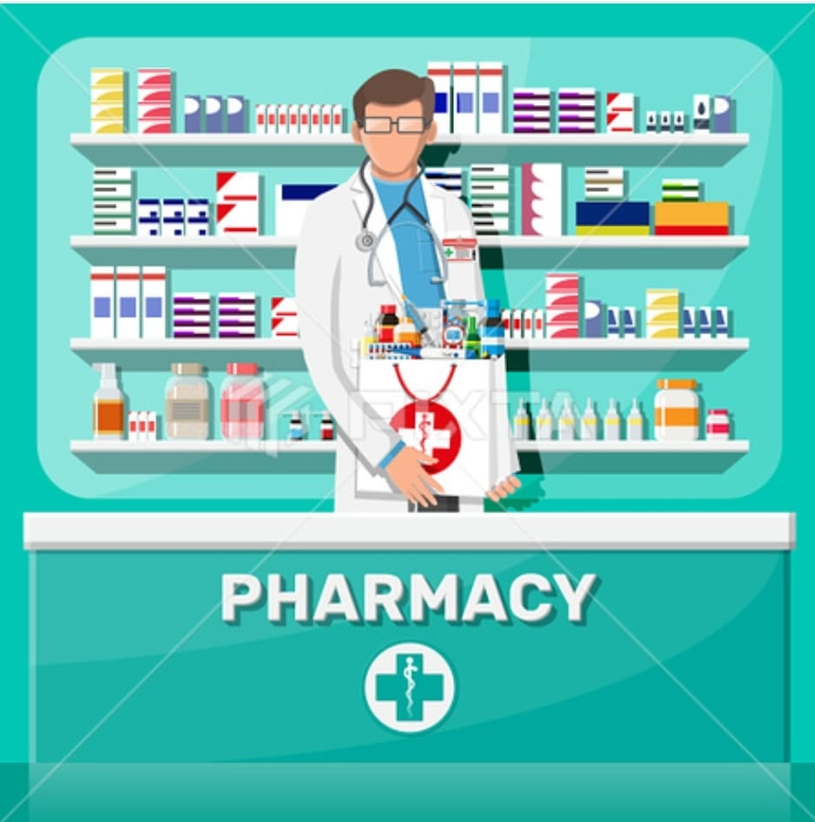

**Name:** Muzammil Chunawala

**Class & Section:** 12-A **Year:** 2021-2022

**THE​ ​NEW​ ​INDIAN​ ​SCHOOL​ ​W.L.L.**

KINGDOM​ ​OF​ ​BAHRAIN

Certificate of Completion



Senior Secondary School, Affiliated to CBSE, New Delhi

This​ ​is​ ​to​ ​certify​ ​that​​ ​​ **Muzammil Chunawala** of class​​ **​​​​XII- ​A​ ​**has

successfully​ ​completed **COMPUTER SCIENCE** ​Project​ ​on​ ​the​

topic​​ **Pharmacy Management System** for​ ​the​ ​academic​ ​year​​ ​​**2022-2023** ​​​​.

Internal​ ​Examiner​ ​​ ​​ ​​ ​​ ​​ ​​ ​​ ​​ ​​ ​​ ​​ ​​ ​​ ​​ ​​ ​​ ​​ ​​ ​​ ​​ ​​ ​​ ​​ ​​ ​​ ​​ ​​ ​​ ​​ ​​ ​​ ​​ ​​ ​​ ​​ ​​ ​​ ​​ ​​ ​​ External​ ​Examiner

School Seal:

**PREFACE**

The main objective of any computer science student is to get as much of practical knowledge as possible. Being able to develop a project on our own was an experience of a lifetime. As practical knowledge is as important as theoretical knowledge, I am grateful to be able to utilize both of them in our project.

Through the development of the project, I gained invaluable experience of applying various strategies which helped in the development of the project. This project is the stepping stone for my carrier.

So keeping these things in views, I present to you my project on “**Pharmacy Management System”.** I have maintained this project work on the suitable and advanced language i.e. “Python” with the MySql database connectivity.

Proper care has been taken while organizing the project so that it is easy to comprehend. Also, various concepts involving python programs and MySql databases were also implemented.

**ACKNOWLEDGMENT**

Apart from one’s efforts, the success of any project depends largely on the encouragement and guidance of many others. I take this opportunity to express my gratitude to the people who have been instrumental in the successful completion of this project.

I express a deep sense of gratitude to almighty God for giving me strength for the completion of the project.

I express my heartfelt gratitude to my parents for constant encouragement while carrying out this project.

I gratefully acknowledge the contribution of my teammates in bringing this project up to this level, who have worked hard along with me and spent countless hours on the project.

My sincere thanks to **Mrs. Sujitha Lawrence**, our computer science teacher. for guiding me immensely through the course of my project. Her constructive advice and constant motivation played a crucial part in the successful completion of this project.

The guidance and support received from all the members was vital for the success of the project. I am grateful for their constant support and help.

**INDEX**

1. Introduction to Python

2. Introduction to Interface Python with MySQL

3. About Project

4. Objectives of the Project

5. Hierarchical Diagram of the Project

6. Feasibility Study

7. Data Structure

8. Hardware and Software requirement

9. Source Code

10. Output Screens

11. Bibliography

**1.INTRODUCTION TO PYTHON**

It can model real-world entities being an object-oriented programming language. It is also dynamically typed, carries out type-checking at run-time.

Python is interpreted language that executes one line at a time in the Python Integrated Development Environment(IDLE).

***Advantages of Python***

**1.Better Data Security**

As number of users increases data transferring or data sharing rate also increases thus increasing the risk of data security. It’s widely used in corporation world where companies invest money, time and effort in large amount to ensure data is secure and is used properly

A Database Management System provide a better platform for data privacy and security policies thus, helping companies to improve Data Security.

**2. Better Data Integration**

Due to Database Management System we have an access to well managed and synchronized form of data thus makes data handling very easy and gives integrated view of how a particular organization is working and also helps to keep a track on how one segment of the company affects the other segment.

**3. Minimized Dates Inconsistency**

Data inconsistency occurs between files when different versions of the same data appear in different places.

So if a database is properly designed then Data inconsistent can be greatly reduced hence minimizing data inconsistency.

**4. Increase end-user productivity**

The data which is available with the help of combination of tools which transform data into useful information, helps end user to make quick, informative and better decisions that can make difference between success and failure in the global economy.

**Conclusion**

Python’s use is just like a helpful assistant is handling you tools. It serves as a glue language for beginner and experts to come together and collaborate for scientific development.

**2.INTRODUCTION TO INTERFACE PYTHON WITH MYSQL**

A database is nothing but an organized collection of data. Data is organized into rows, columns and tables and it is indexed to make it easier to find relevant information. All companies whether large or small use databases. So it becomes necessary to develop project/software using any programming language like python in such a manner which can interface with such databases which support SQL. Generalised form of Interface of Python with SQL Databases can be understood with the help of this diagram.

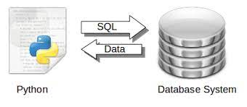

Form/any user interface designed in any programming language is Front End whereas data given by database as response is known as Back-Ended database.

SQL is just a query language it is not a database. To perform SQL queries we need to install any database for example Oracle, MySQL, MongoDB, PostGres SQL, SQL Server, DB2 etc.

Using SQL in any of the DBMS, databases and table can be created and data can be accessed, updated and maintained. The Python standard for database interfaces is the Python DB-API

***Why choose Python for database programming:***

Following are the reason to choose python for database programming

* Programming more efficient and faster compared to other languages.
* Portability of python program.
* Support platform independent program development
* Python supports SQL cursors
* Python itself take care of open and close of connections

**3.ABOUT PROJECT**

Today one cannot afford to rely on the fallible and incompetent nature of human beings on carrying out crucial and complicated tasks without supervision. It has become even harder to survive in the market due to the merciless competition and it’s no longer wise to keep saying “to err is human”. It can cost dearly to rationalize your mistake and continue to keep doing it. So to keep up with time ,bring about the best outcome without malfunctions, produce greater efficiency and productivity and replace the bulky heaps of files, we propose to use a software database management system.

Software has seen an exponential rise in efficiently micromanaging medium to big organizations. Earlier, data management meant maintaining a lot of ledgers and paperwork but in the present scenario software has made things a lot easier and has offloaded a lot of stress from the employees.

In the health sector and especially in pharmacies, less stress means that the employee will work with added focus and dispatch medicines with care. It also helps to increase the employee-customer rapport which in turn helps increase the sales.

It also helps save a lot of time and money. The work becomes fully automated and any information about the establishments can be accessed on the push of a button. Moreover, this helps the organizations to have greater control over their establishments and helps prevent any malpractices.

**4.Objectives Of The Project**

Our consideration while developing this software project is to achieve the following points:

* This software is all about pharmacy management system. It provides all the facilities that are very important in a pharmacy.
* User can manage all the all the records very easily. You can generate all kinds of details like customer details, transaction details, medicine’s expiry details and so on.
* It also helps in having an easy access of records of their employees which could help in visa renewal, salary, incentive and bonuses.
* It also saves the valuable time of the person behind the software.

**5.HIERARCHICAL DIAGRAM OF THE PROJECT**

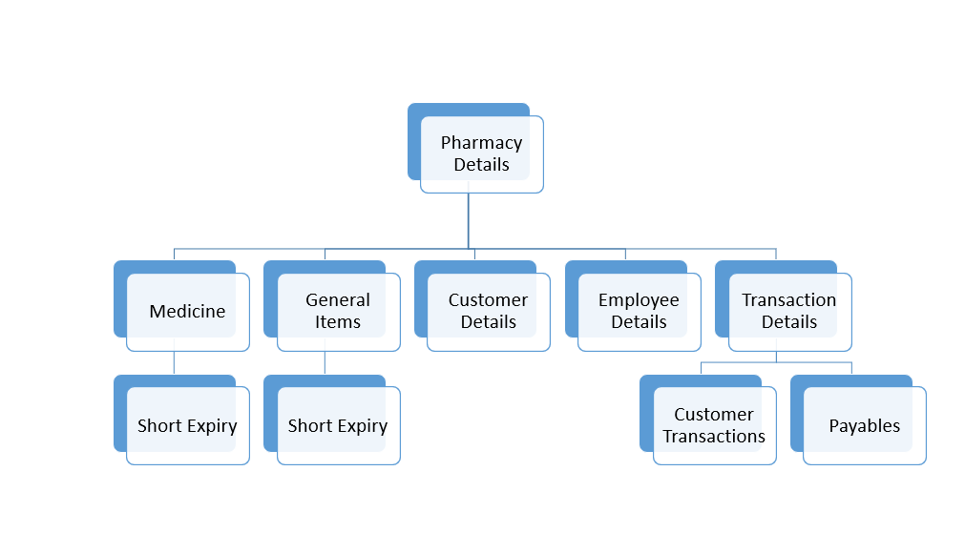

**6.Feasible study**

It has very importantly place in the study of any software because if the project aren’t feasible, then working on this software is not a good work.

So, I conducted this feasible study below in order to check out whether our software “**PHARMACY MANAGEMENT SYSTEM”** is feasible or not. So, we study about three types of feasibility:

* ***Economic Feasibility***
* ***Technical Feasibility***
* ***Operational Feasibility***

So, brief description of above phrases:-

1. **Economic Feasibility:-**

In this study, I was concerned about broad range of factors. For any system if the expected benefits equal or exceed the expected costs, the system can be judged to be economically feasible.

In economic feasibility, cost benefit analysis is done in which expected costs and benefits are evaluated. Economic analysis is used for evaluating the effectiveness of the proposed system. It’s an economic feasible software and saves lots of expenses.

1. **Technical Feasibility:-**

In this study, we check that is the system feasible or not. If the system isn’t feasible then, a system analyst takes a decision about the software that will be proceeding out or not.

Once the technical feasibility is established, it is important to consider the monetary factors also.

Since it might happen that developing a particular system may be technically possible but it may require huge investments and benefits may be less. For evaluating this, economic feasibility of the proposed system is carried out.

1. **Operational feasibility:-**

Our software is user friendly. So a person who does not have any technical background can operate this software, prior knowledge of computer is not mandatory for operating the software.

Icons menus and its options describing its meaning itself, input and output form are designed in user friendly way for providing proper instructions with user. So, we specially take care of that software is operational feasible.

**7. DATA STRUCTURE**

**1. Entity of Pharmacy Management System:**

Pharmacy directory, employee details, Medicines, General items, short expiry, transaction history.

**2. Attributes Entities and their structure:**

**1. Pharmacy** (CR_no, Ph_Name, Ph_add, );

**2.CUSTOMER** ( Cust_id, Cust_Name, Cust_add, Cust_mno, Cust_pres);

**3. Medicines** (Med_id, Med_exp, Med_comp, Med_Name, Med_details, Med_dist, Med_qnt, Med_status);

**4. General items** (Gen_id, Gen _comp, Gen _Name, Gen _details, Gen _dist, Gen _qnt, Gen _status);

**5. EMPLOYEE** (EMP_id, EMP_Name, EMP_add, EMP_mno, EMP_Salary, Emp_job, EMP_dob, Emp_visaexp);

**6. TRANSACTION** (trans_id, trans_amt, trans_type, trans_item, trans_qnt trans_date);

**7. Short expiry** (Med_id, Med_exp, Med_comp, Med_Name, Med_details, Med_dist, Med_qnt, Med_status)

**Pharmacy Module:**

This table contains pharmacy related information

|  |  |  |  |
| --- | --- | --- | --- |
| Attribute | Data types | Size | Constraint |
| Cr_no | **Integer** | **10 byte** | Primnary key |
| Ph_Name | **String** | **30 byte** | Not Null |
| Ph_add | **String** | **70 byte** | Not Null |
| Ph_telno | Integer | 10 byte | Not Null |

**Customer Module :**

This table contains Customer related information

|  |  |  |  |
| --- | --- | --- | --- |
| Attribute | Data types | Size | Constraint |
| Cust_id | **Integer** | **10bytes** | Primnary key |
| Cust_Name | **String** | **30 bytes** | Not Null |
| Cust_Add | **String** | **70 bytes** | Not Null |
| Cust_Pno | **Integer** | **10 bytes** | Not Null |
| Cust_pres | String | 50 bytes | - |

**Employee Module:**

|  |  |  |  |
| --- | --- | --- | --- |
| Attribute | Data types | Size | Constraint |
| EMP_id | **Integer** | **10 bytes** | Primnary key |
| EMP_Name, Emp_visaexp | **String** | **30 bytes** | Not Null |
| EMP_add | **String** | **70 bytes** | Not Null  Not Null |
| EMP_mno | **Integer** | **10 bytes** | Not Null |
| EMP_Salary | **Integer** | **10 bytes** | Not Null |
| Emp_job | **String** | **10 bytes** | Not Null |
| EMP_dob | **Date** | **10 bytes** | Not Null |
| Emp_visaexp | Date | 10 bytes | Not Null |

This contains information regarding the employees.

**Medicine Module:**

|  |  |  |  |
| --- | --- | --- | --- |
| Attribute | Data types | Size | Constraint |
| Med_id | **Integer** | **10 bytes** | Primary key |
| Med_exp | **Date** | **10 bytes** | Not Null |
| Med_comp | **String** | **20 bytes** | Not Null |
| Med_Name | **String** | **20 bytes** | Not Null |
| Med_details | **String** | **30 bytes** | Not Null |
| Med_dist | **String** | **30 bytes** | Not Null |
| Med_qnt | **Integer** | **10 bytes** | Not Null |
| Med_price | String | 10 bytes | Not Null |

This table gives information about the medicines.

**General Items Module:**

This table gives information about the general items.

|  |  |  |  |
| --- | --- | --- | --- |
| Attribute | Data types | Size | Constraint |
| Gen_id | **Integer** | **10 bytes** | Primary key |
| Gen_exp | **Date** | **10 bytes** | Not Null |
| Gen_comp | **String** | **20 bytes** | Not Null |
| Gen_Name | **String** | **20 bytes** | Not Null |
| Gen_details | **String** | **30 bytes** | Not Null |
| Gen_dist | **String** | **30 bytes** | Not Null |
| Gen_qnt | **Integer** | **10 bytes** | Not Null |
| Gen_price | String | 10 bytes | Not Null |

**Transaction module:**

This gives information about the transactions within the pharmacies.

|  |  |  |  |
| --- | --- | --- | --- |
| Attribute | Data types | Size | Constraint |
| trans_id | **Integer** | **10 bytes** | Primary key |
| trans_amt | **Integer** | **10 bytes** | Not Null |
| trans_type | **String** | **20 bytes** | Not Null |
| trans_item | **String** | **30 bytes** | Not Null |
| trans_qnt | **Integer** | **10 bytes** | Not Null |
| trans_date | Date | 10 bytes | Not Null |

**8. HARDWARE AND SOFTWARE REQUIREMENT**

**Hardware:**

1. Processor
2. Keyboard
3. Minimum memory – 4GB

**Software:**

1. Operating system – WINDOWS10
2. Python IDLE
3. MYSQL

**9. SOURCE CODE**

1.Initialising Table in MySQL using python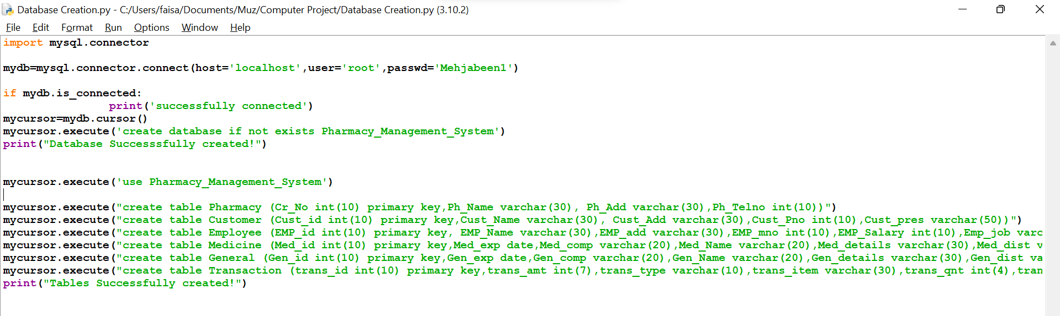

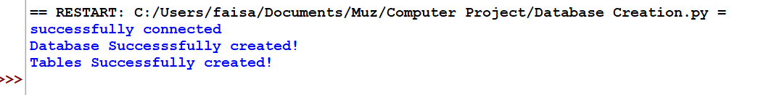

2.Main Source Code

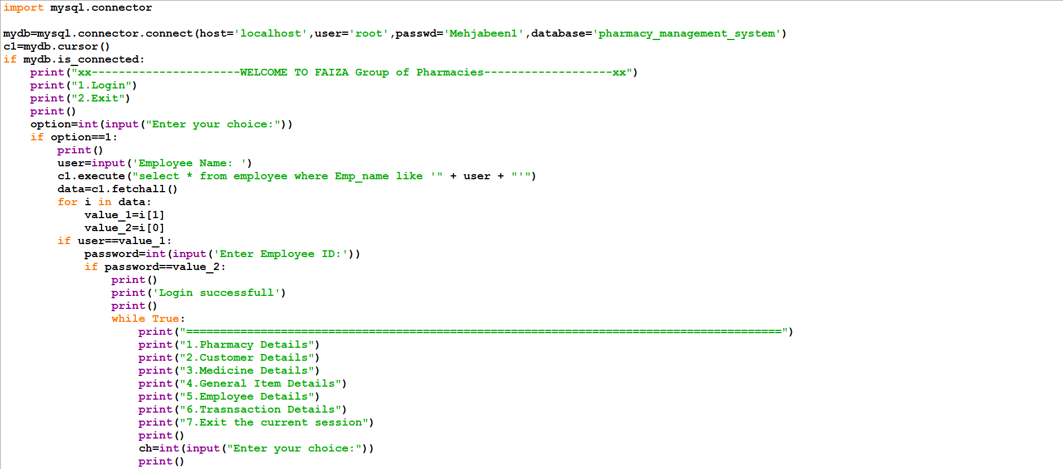

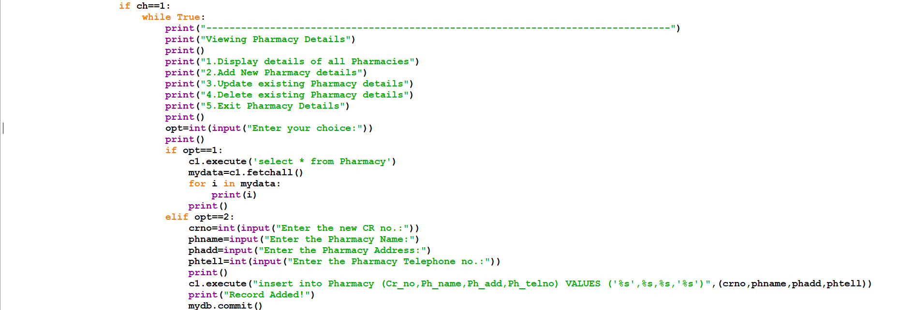

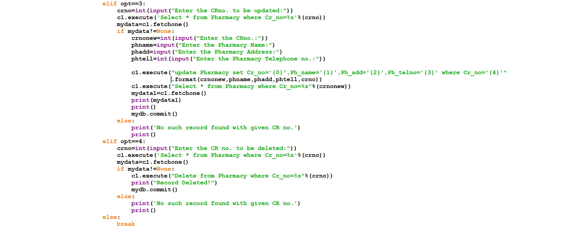

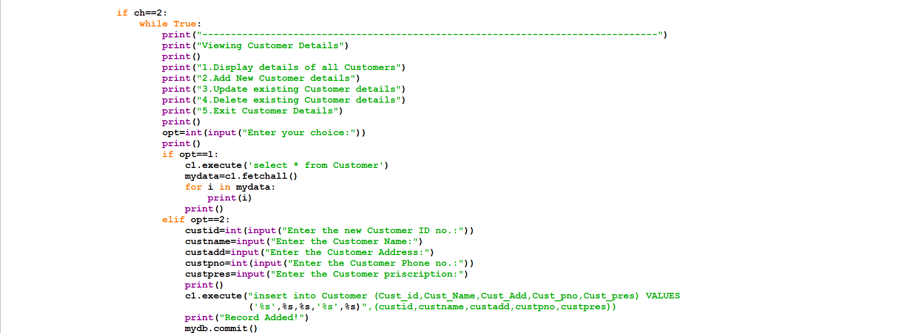

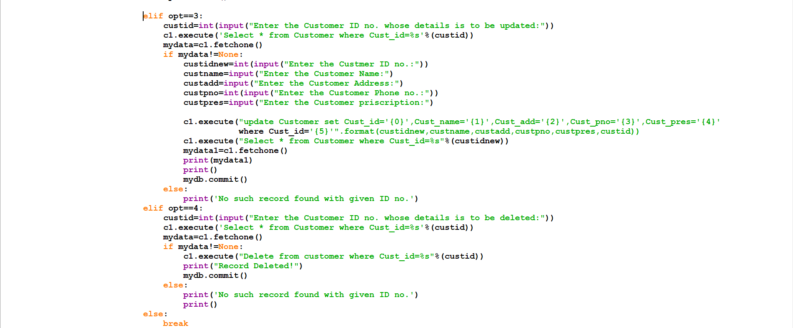

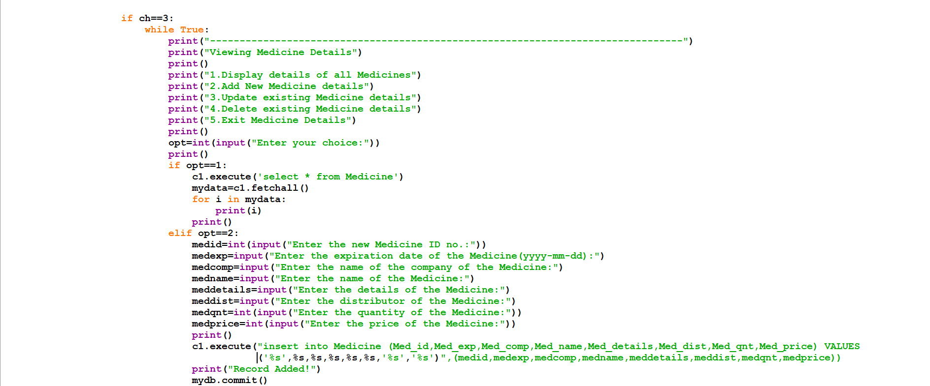

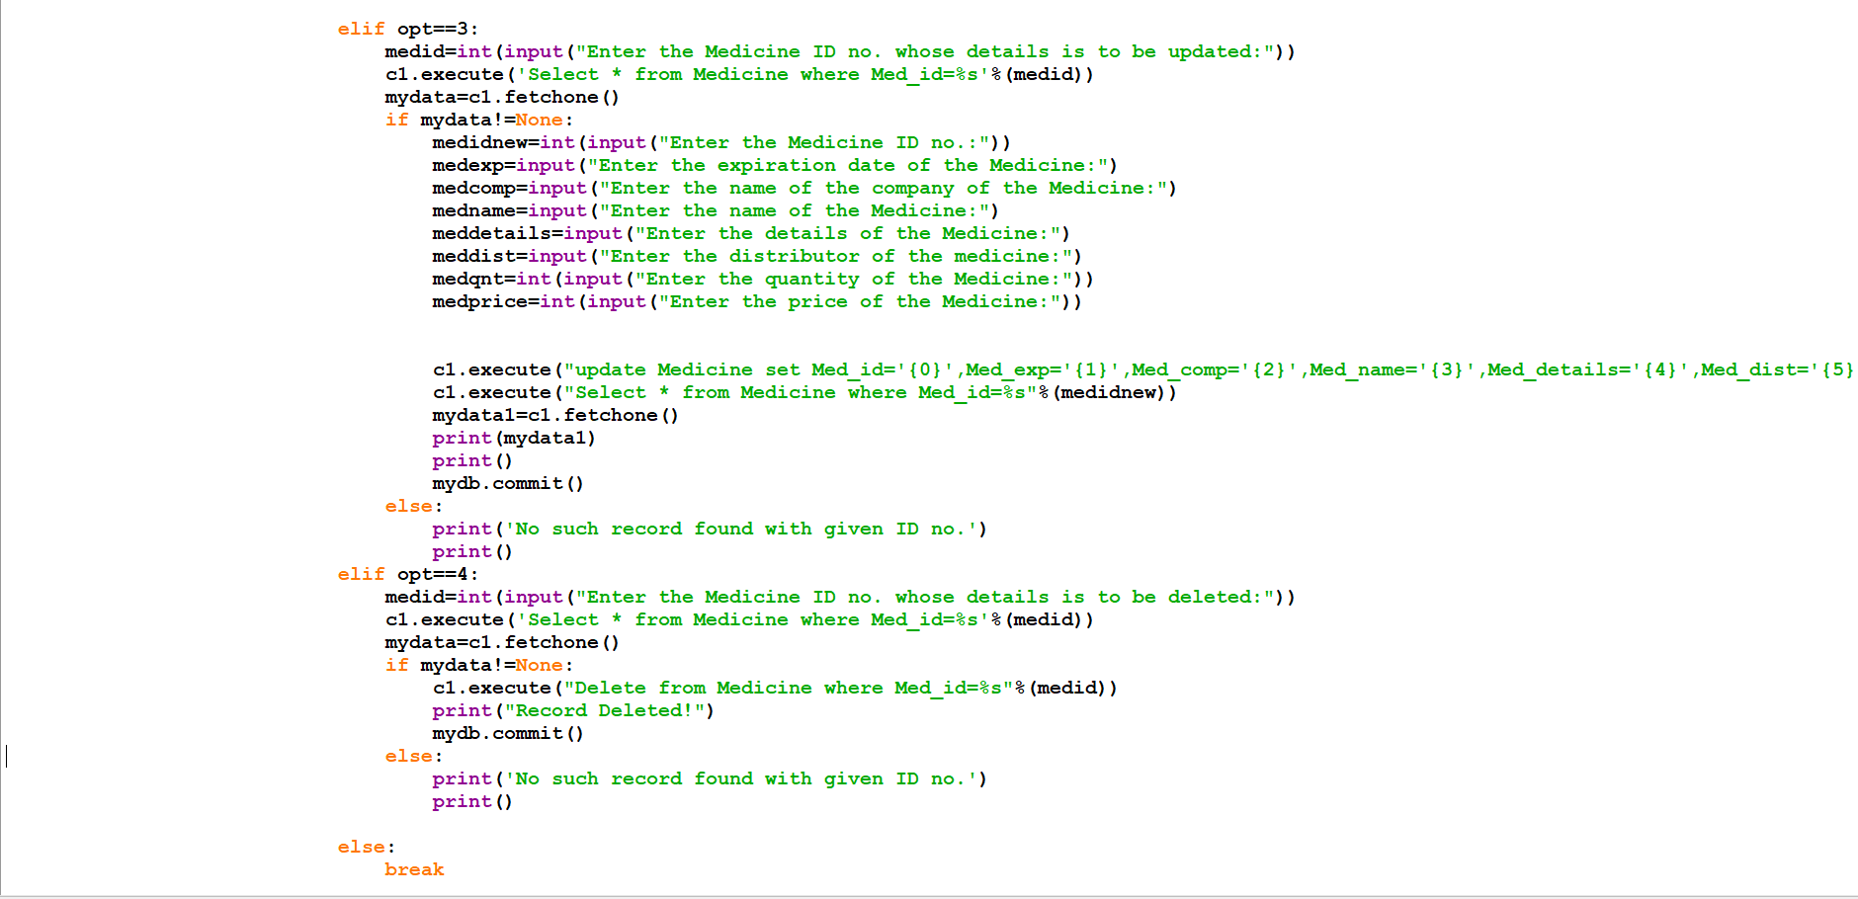

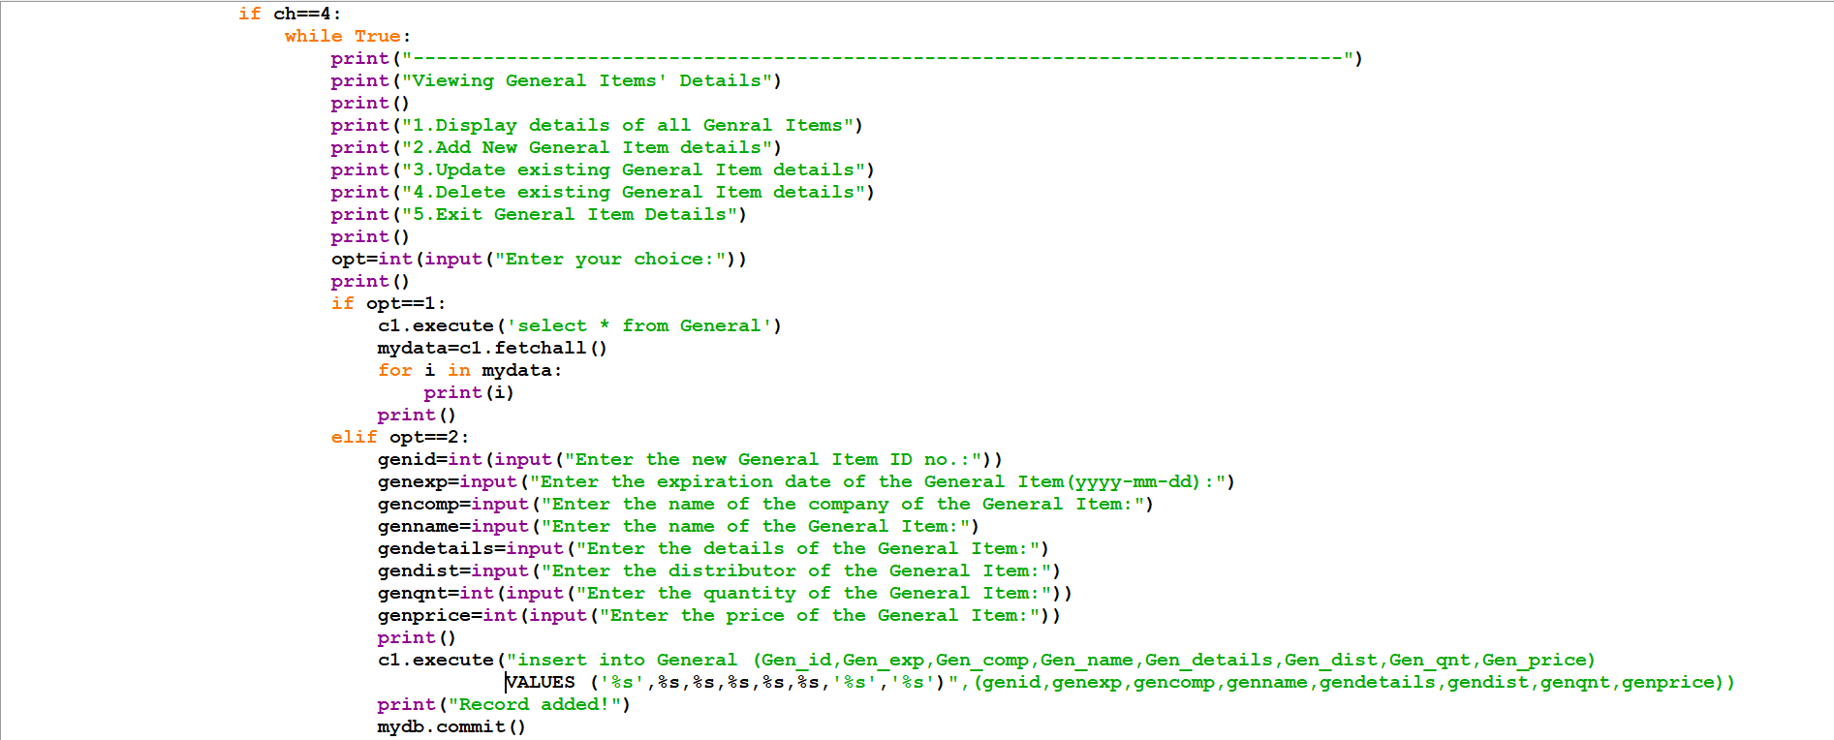

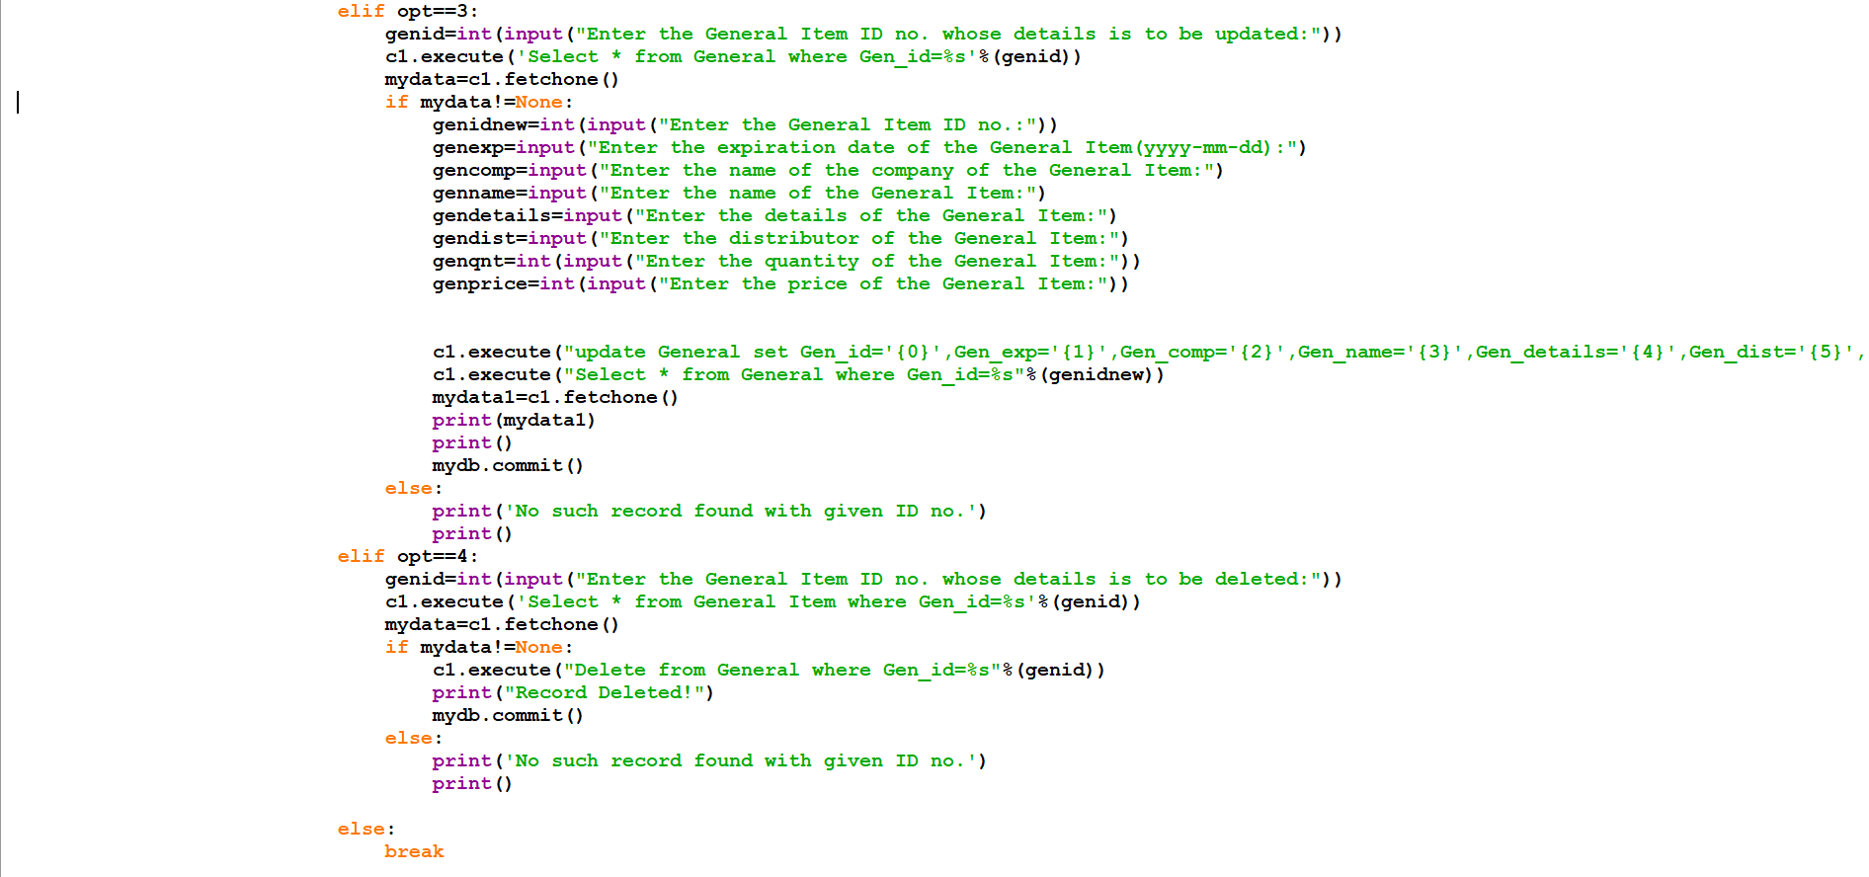

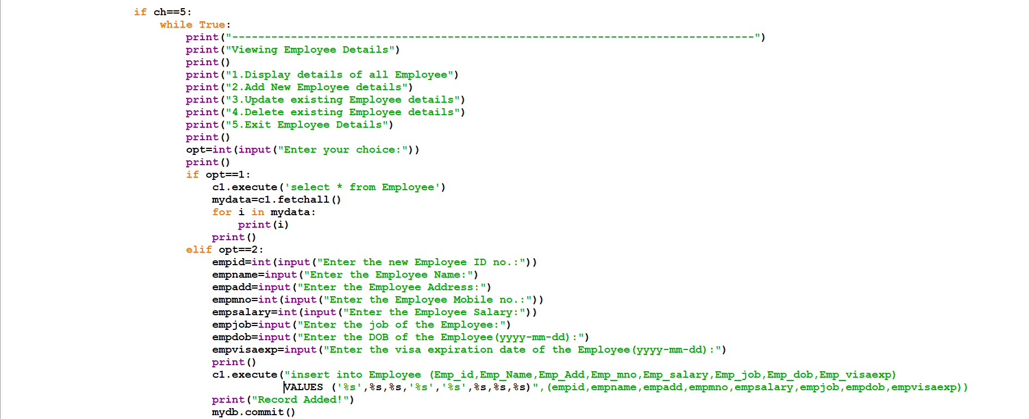

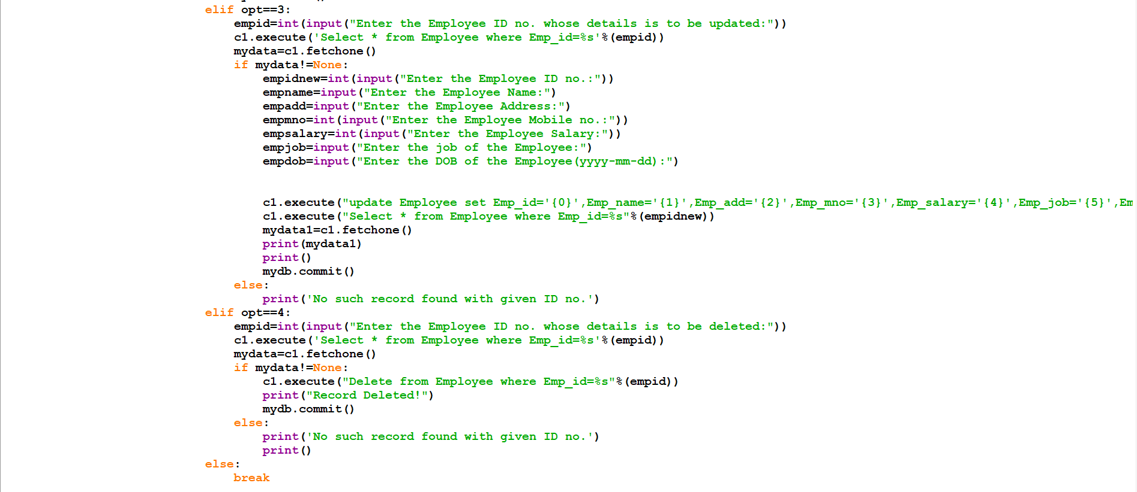

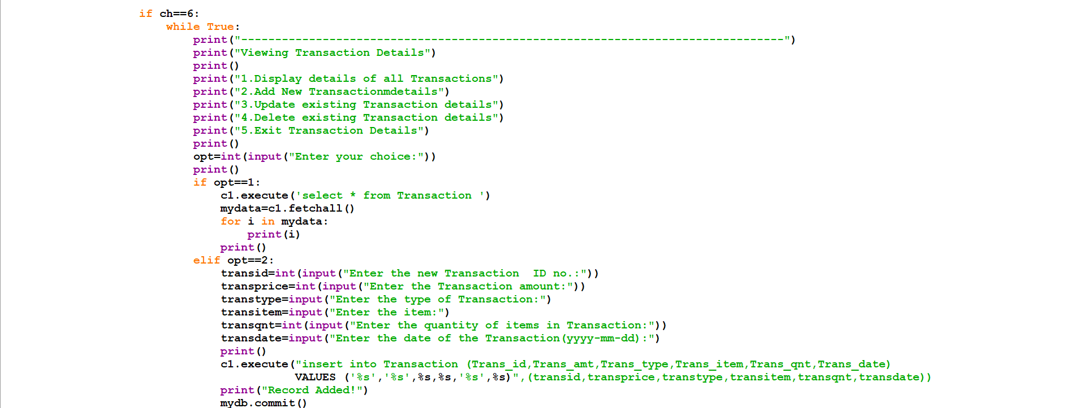

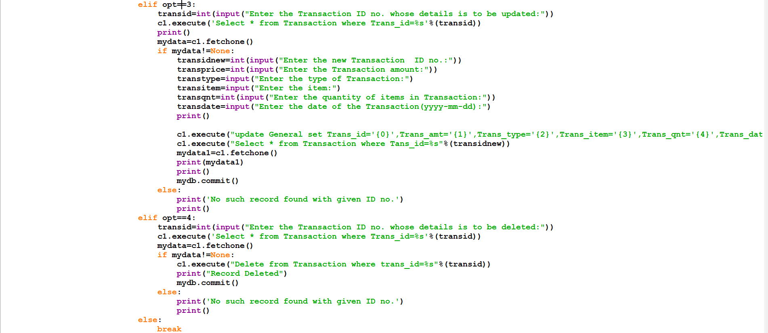

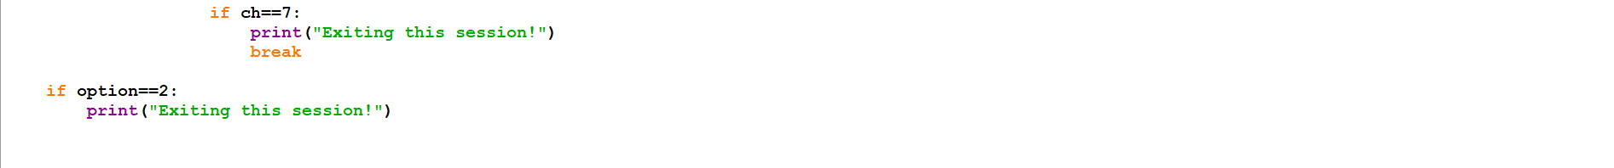

**10. OUTPUT SCREENS**

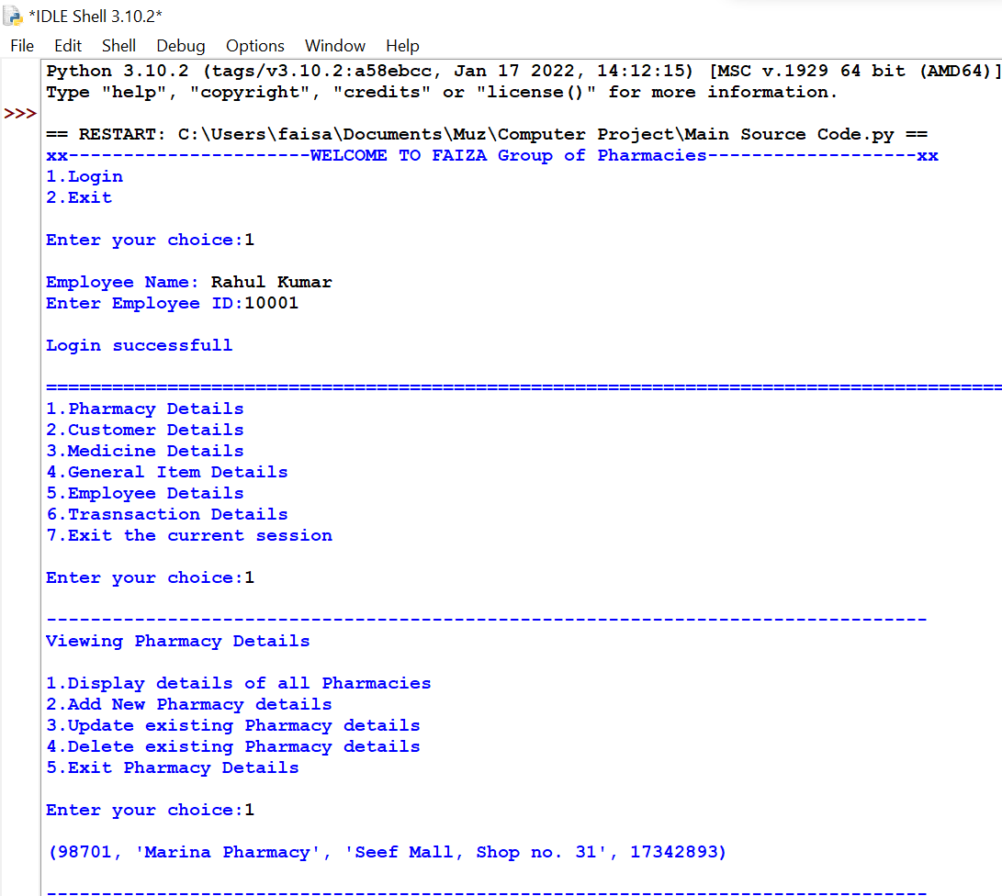

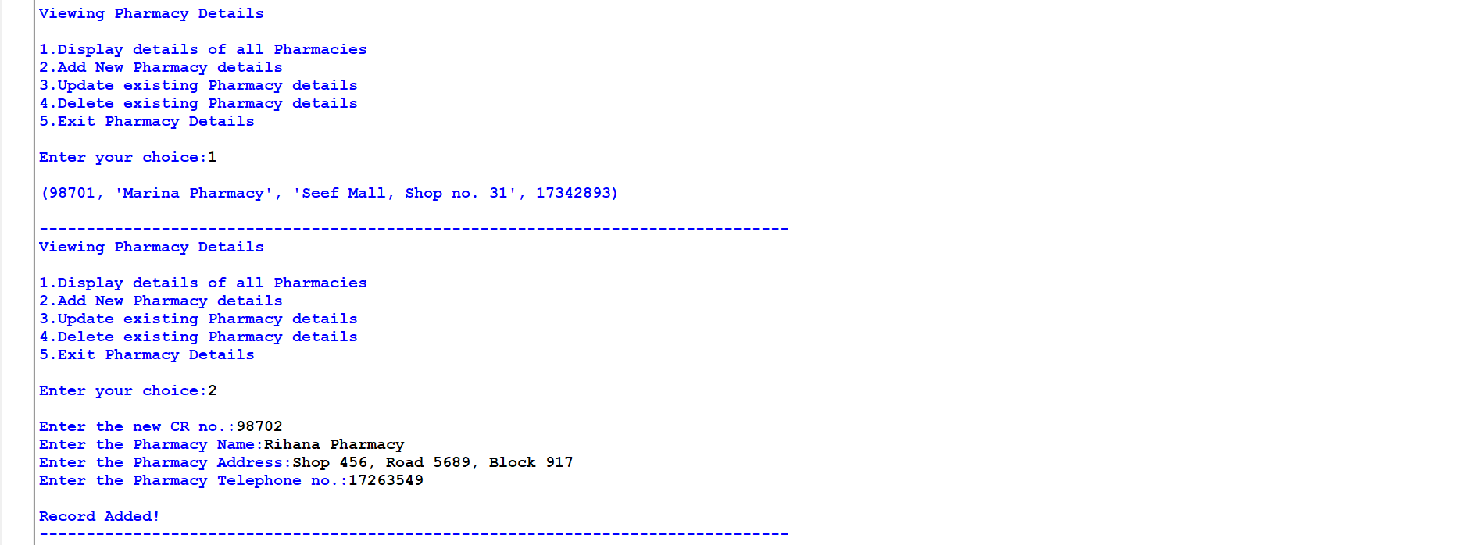

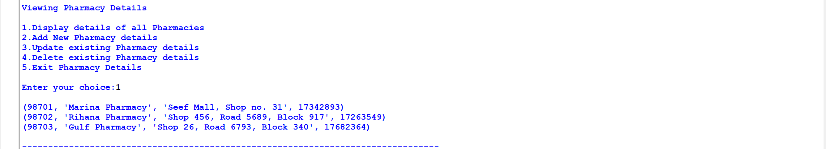

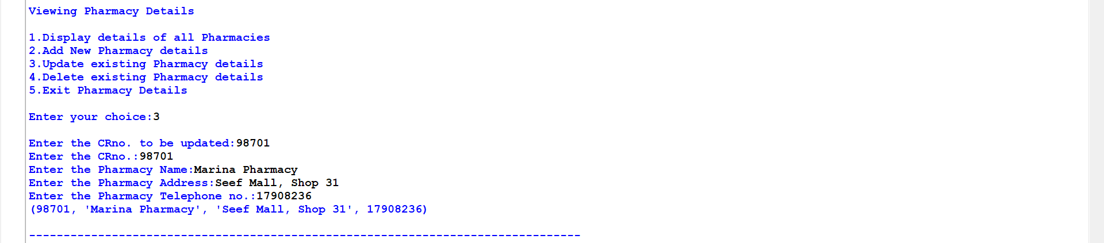

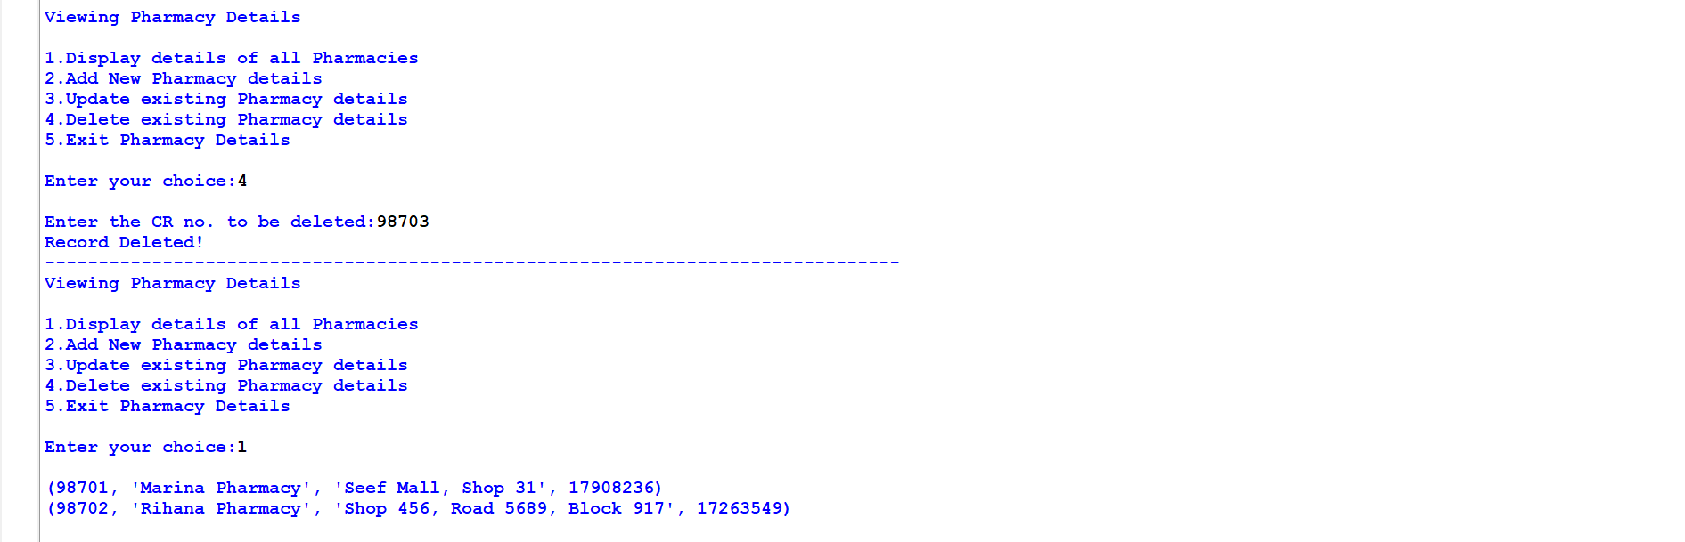

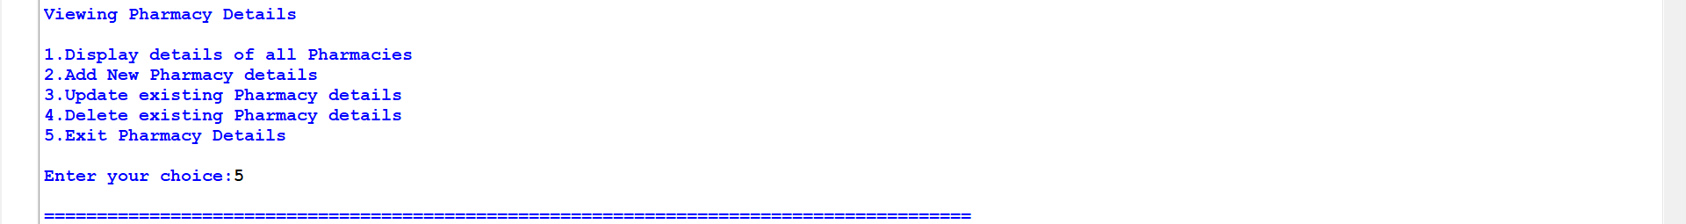

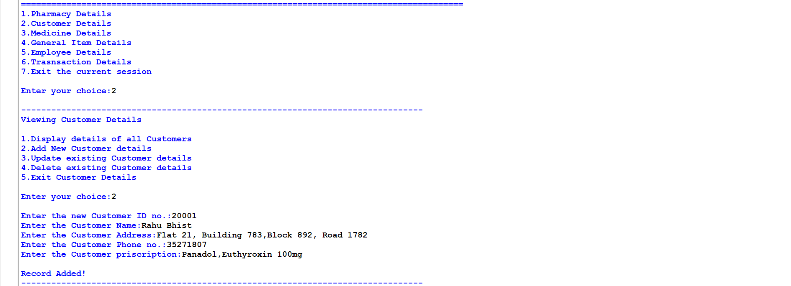

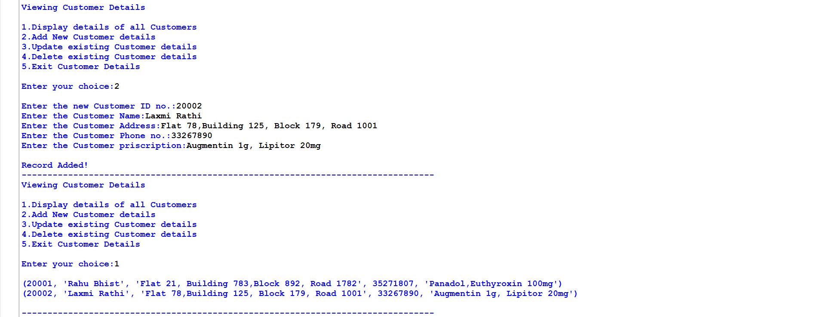

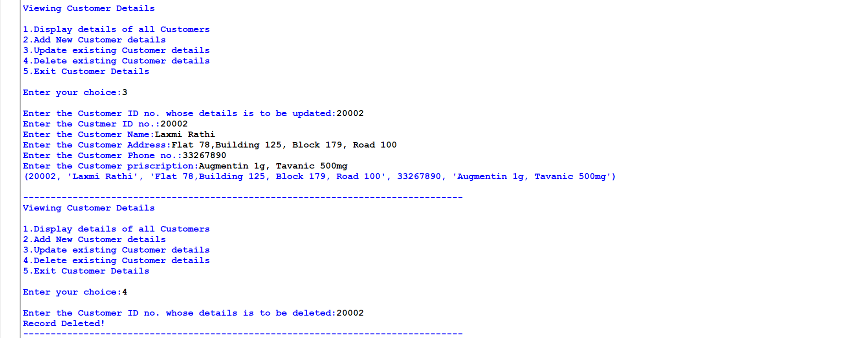

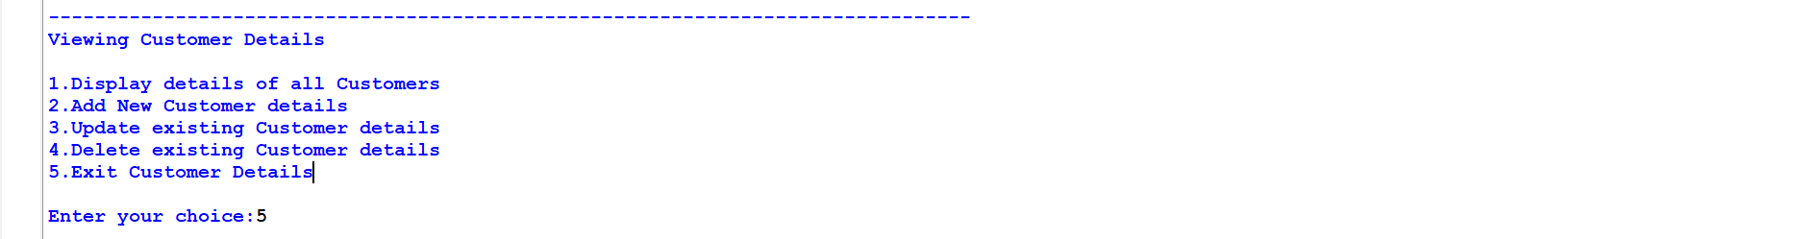

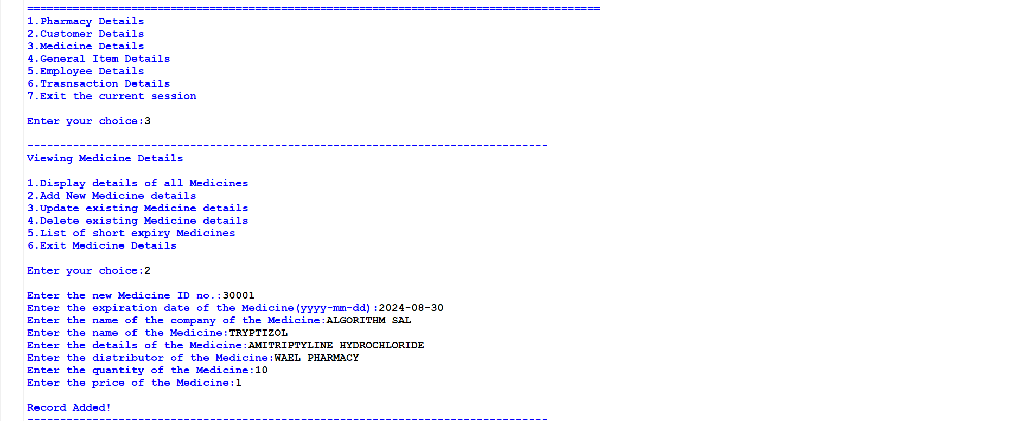

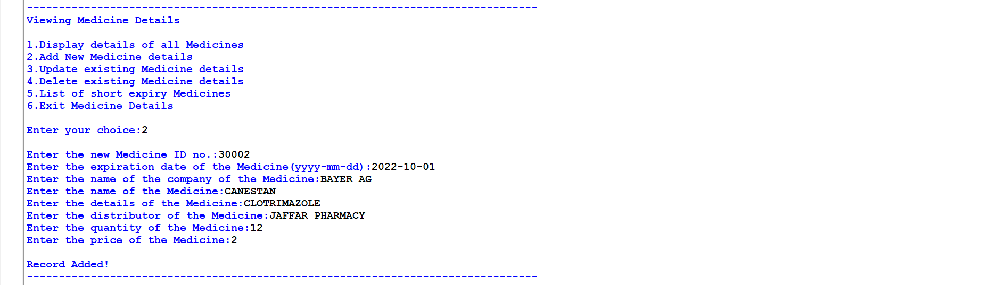

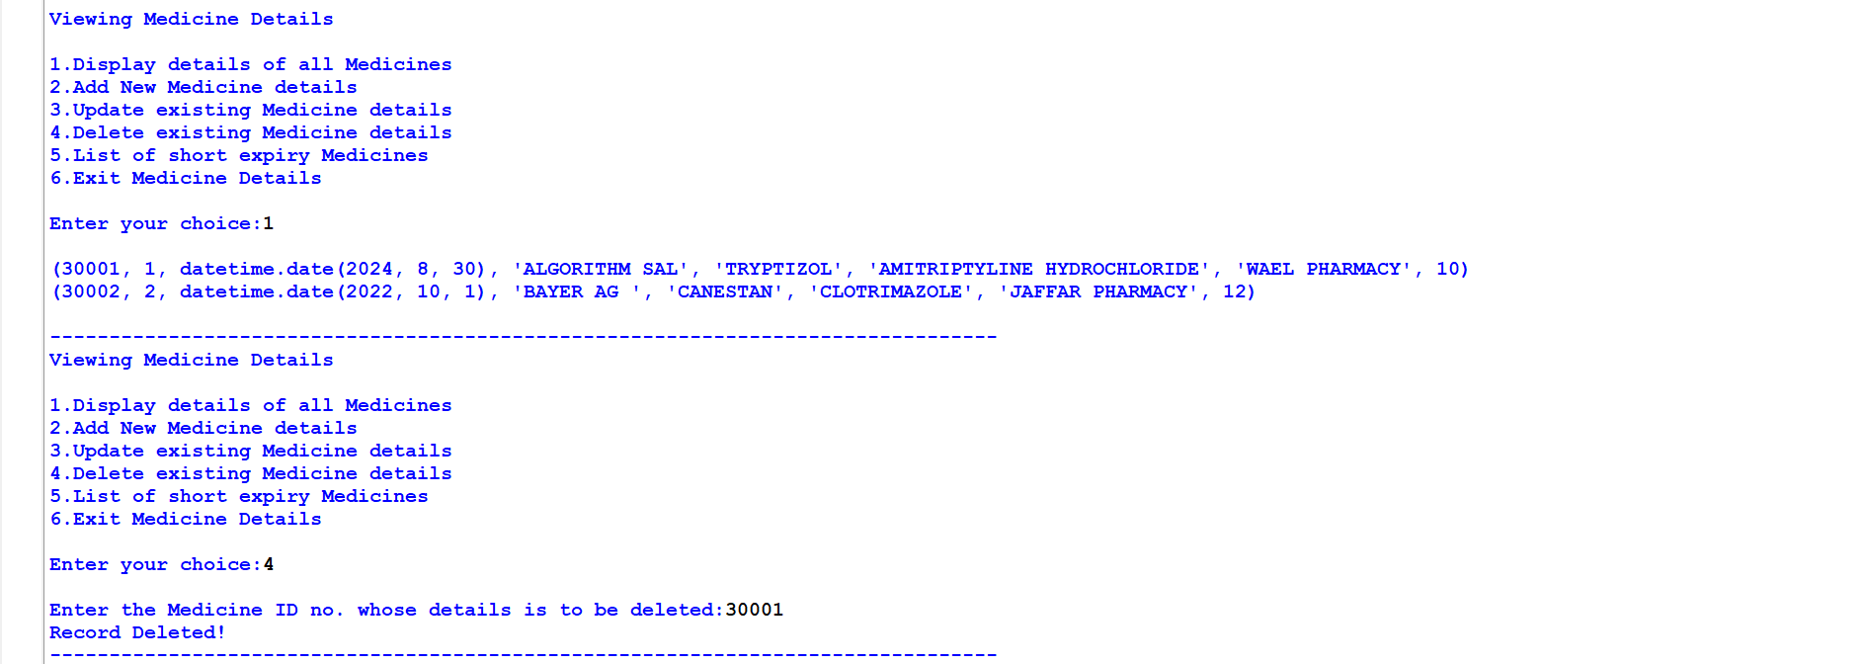

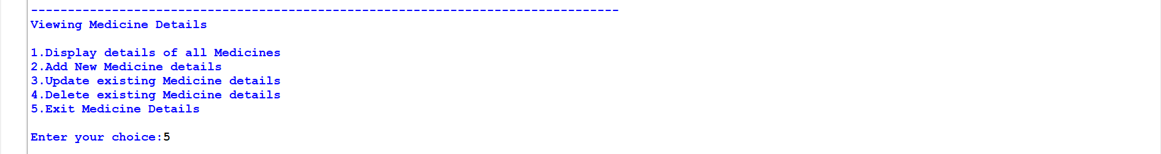

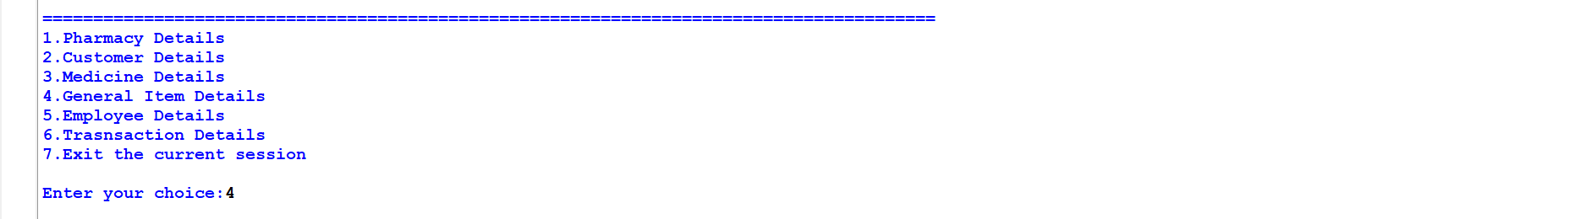

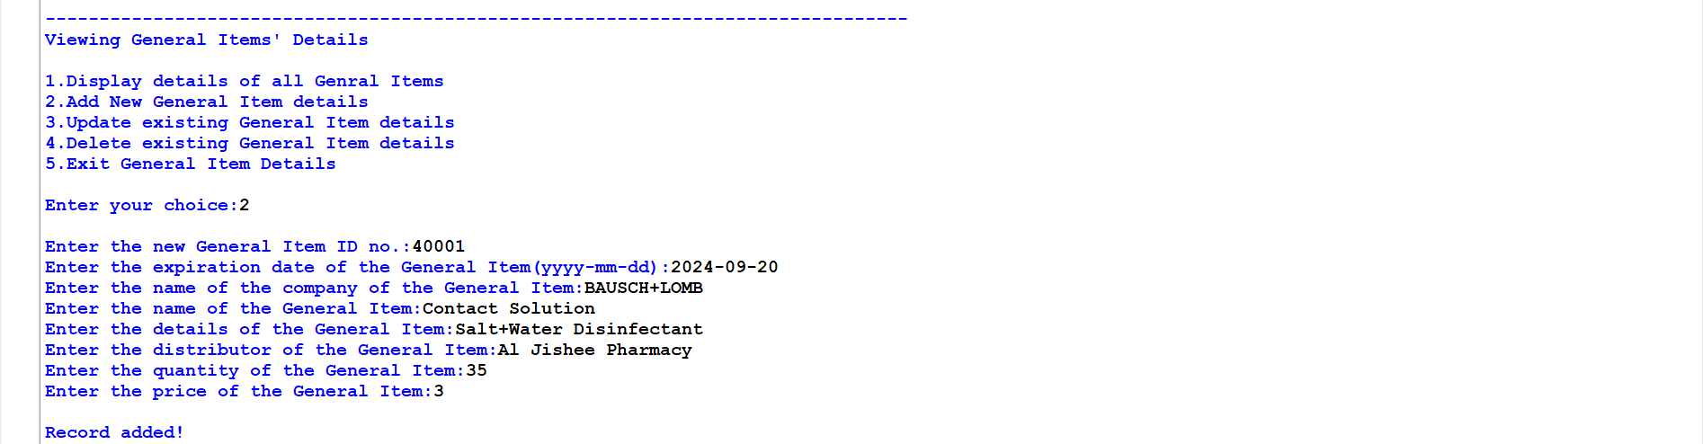

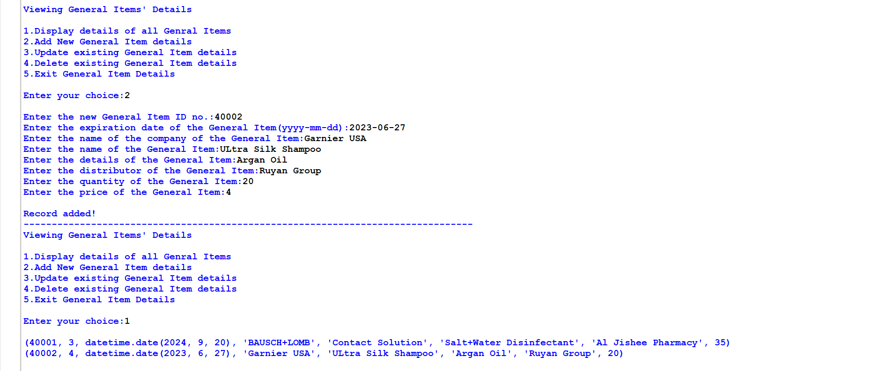

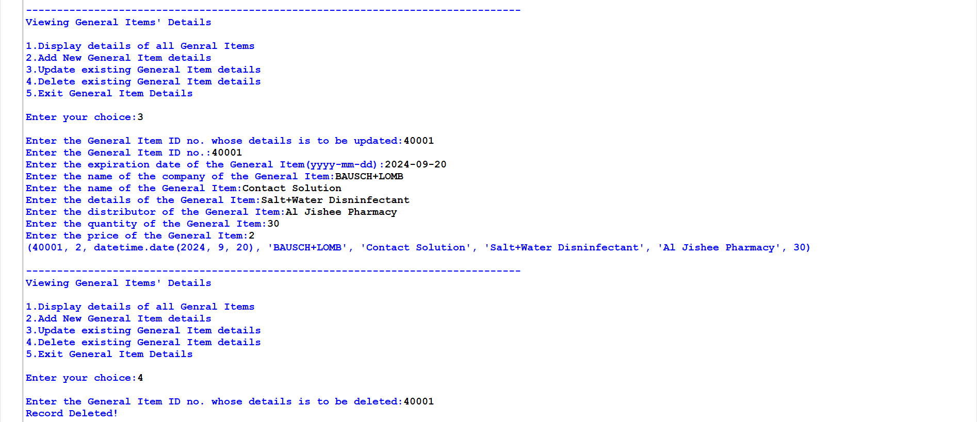

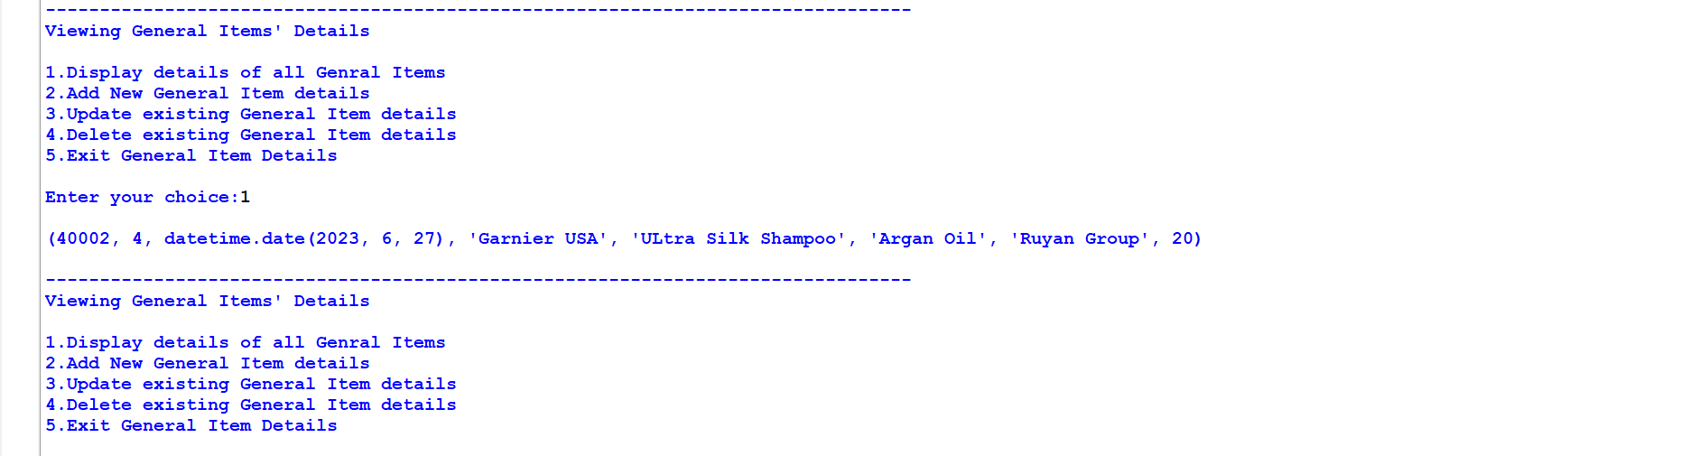

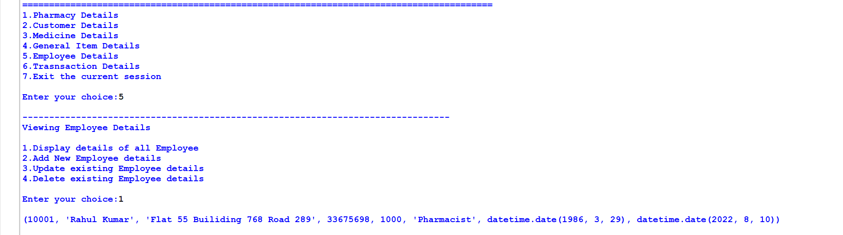

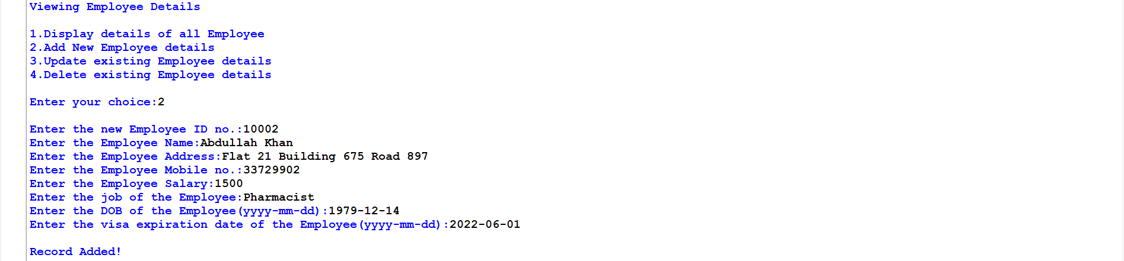

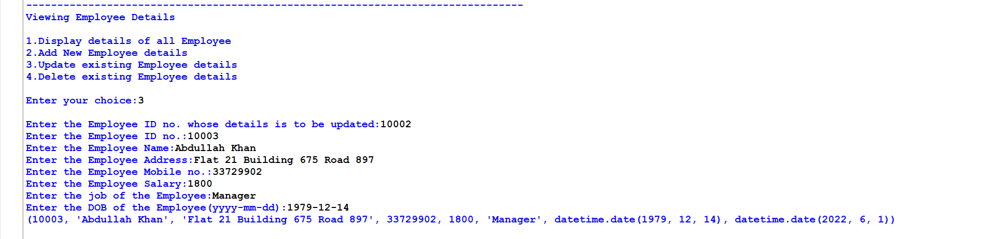

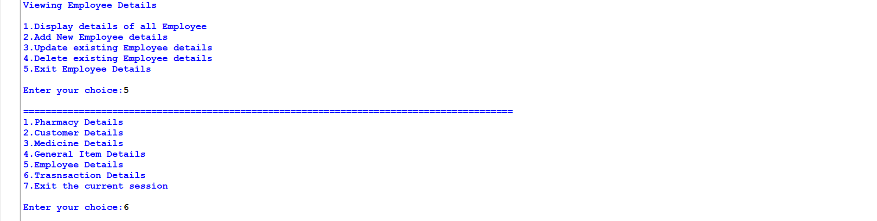

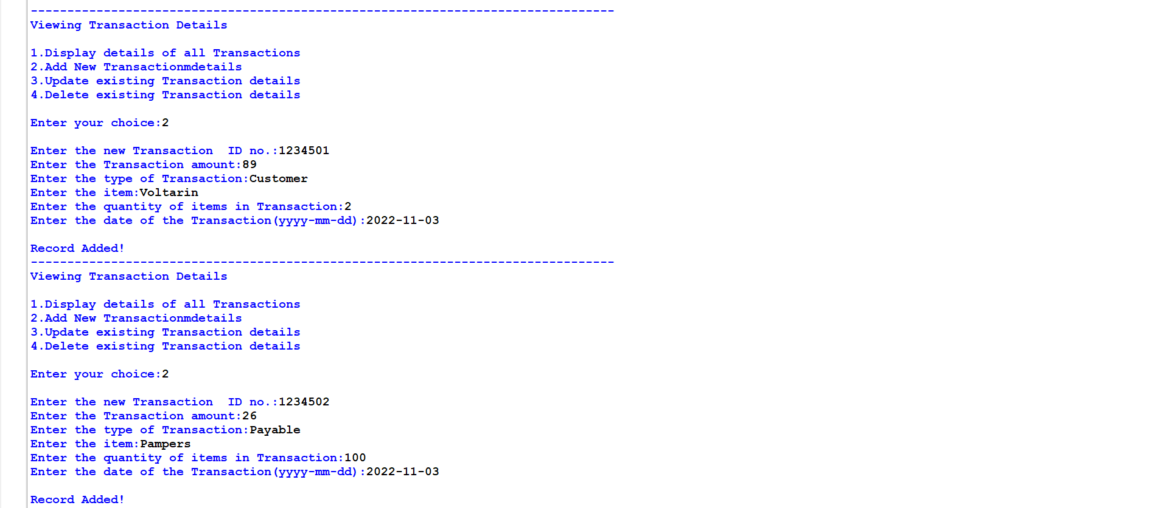

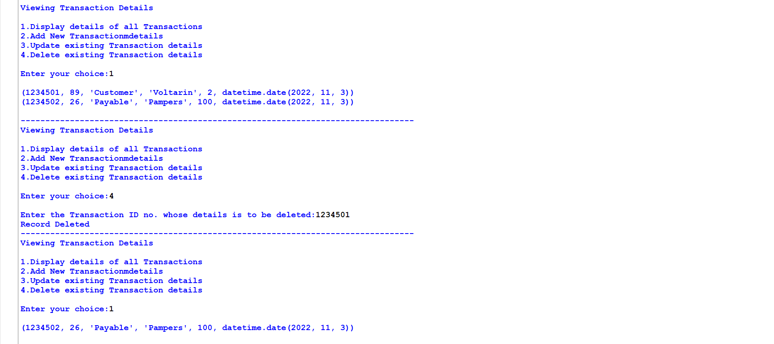

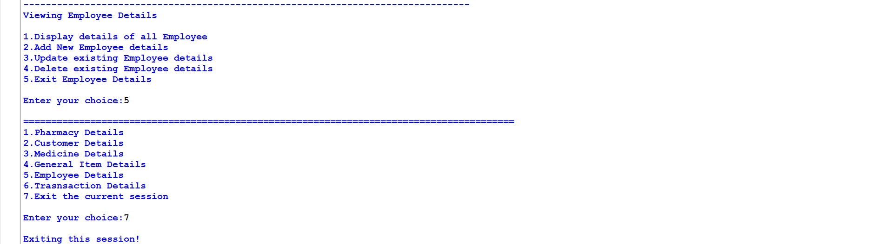

**11. BIBLIOGRAPHY**

**http://python.mykvs.in**

<https://pythonworld.in/>

https://stackoverflow.com/